Welcome To The

Elkridge Volunteer
Fire Department

Junior Firefighter Program

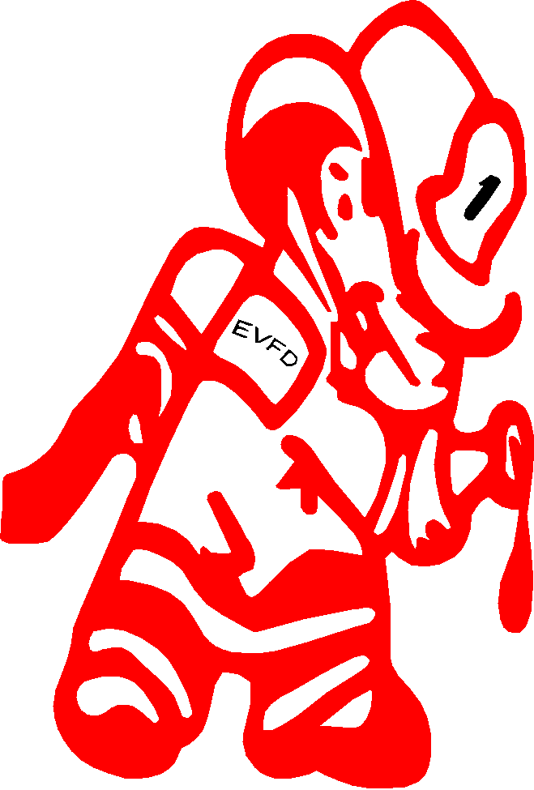

New Members Booklet

New Member,

As the Coordinator of the Junior Firefighter Program, I would like to take this opportunity to welcome you as a Junior member of the Elkridge Volunteer Fire Department! For many, this program will be the first step in the career to the fire service, whether volunteer or paid. I honestly believe that you as an active participant in this program are the future of this fire department, and a hero of tomorrow.

When people do not know where to turn for help, quite often their response is to call the local fire department. They expect us to fix their emergency, or to at least make things better for them. Therefore, the firefighter has traditionally performed many tasks other than just fighting actual fires, and is held in high esteem by many people. As a member of the Junior Program, people will look to you as a representative of this department. Therefore it is important to follow the code of conduct and to be courteous and respectful to all, especially when wearing your uniform.

As a new member of the Junior Program, you will be required to participate in trainings, meetings, drills, fundraising events and station projects. There are also many other activities and opportunities available to you, that I hope you will take advantage of.

As a member of this department I take a great deal of pride in it and the community that surrounds it. You will be expected to do the same. As a member; strive for excellence; be the best that you can; be proud of what you are doing it for; promote department pride by example; and most of all have fun and be safe. Again from myself, my staff, the Chief, and the entire department we welcome you.

Sincerely,

The Coordinator of the Elkridge Volunteer Fire Department,
Junior Firefighter Program

Table of Contents

Page
How It All Began ………………………..….. 1

Mission and Values Statement …………..…. 2

Code of Conduct ………………………….... 3

Platoons …………………………………….. 4

PAT Tags ……………………………..……. 5

Meetings and Trainings ………………..…… 6

Uniforms and Protective Equipment …..…… 7

Point System ……………………………..… 9

FAQs ……………………………………..… 10

How It All Began . . .

The Fire Department began in 1942 at which time America was at war with Germany and Japan. Stories of the war were provided by radio. At that time, the threat of enemy air raid attacks in an area such as Elkridge were very real because of Elkridge being so close to industrial Baltimore and the nation’s capital. If an attack would occur, Elkridge would have to rely on the services of other area fire department’s services.

On April 8, 1942, a meeting was called by Dr. Charles Nitsch, Lewis C. Toomey, Sr., and John F. O’Malley. The meeting was attended by twenty-one (21) men from the areas of Elkridge, West Elkridge, Hanover, Harwood and Lawyers Hill to consider the advisability of establishing a Volunteer Fire Department. A second meeting took place on April 29, 1942, with the guest speaker being Chief John H. O’Lexey, Chief from the Jessup Volunteer Fire Department. Chief O’Lexey spoke about the organization of the Jessup Fire Department and the financing of the equipment. It was noted that approximately $7,000.00 would be needed to start the Fire Department. Before the meeting ended, the men founded the Elkridge Volunteer Fire Department Association and committees were formed to see what money could be raised for a second hand truck and other basic firefighting equipment. Through countless efforts of local and Civil defense officials, the plans for construction for the first piece of equipment were put into action. This engine would become known as “Daisy”. The Fire Department was in business.

The first call was an air raid alert on November 6, 1942. The first fire call was later that day. It was a woods fire caused by target shooting at 3:20 p.m. On January 14, 1943, the department went from operating under the guidelines of the Civil Defense to a permanent, independent organization. This idea was approved and the charter was drawn up by C. F. Sybert. A committee drew up the constitution and bylaws and on February 25, 1943, the department was officially incorporated and Edward Falter took over the position of Chief.

Over the years since “Daisy” rolled out, there have been many changes in firefighting. The equipment used today is that of modern technology. What makes a good firefighter? What kind of people run into burning buildings when everyone else is running out? DEDICATED PEOPLE. Firefighters will leave their home and families, comfort and security for any unknown situation. They do this with skill and courage and they also do this to help others in dire need. Extreme devotion is what every good firefighter needs.

Some of the names if you research back in history are still involved in our department today. This is a family based organization where the upcoming generations are following in the past generations footsteps.

Mission and Values

The Elkridge Volunteer Fire Department and its Junior Firefighter Program work in cooperation to Educate, Protect and Serve the youth of Elkridge and surrounding communities.

The following statements are upheld by the Elkridge Volunteer Fire Department:

MISSION STATEMENT

To maintain a safe environment for youth to gather within the community to learn about many aspects of the fire service and to provide avenues for positive social interaction for youth within the program, and for youth within the community.

VISION

We will be a model for fire departments with Junior Firefighter youth programs to introduce the young community to the fire service and to provide a safe environment for social activities for youth within our community.

CORE VALUES

Recognizing the dedication and skill and value of all members, we will create and maintain an environment of individual safety, well-being and trust. We are guided by: Service to Others, Team Work, Compassion, Integrity, Safety, Honesty, Accountability, Professionalism and Respect.

COMMITMENT TO THE COMMUNITY

The members of the Elkridge Volunteer Fire Department Junior Firefighter Program demonstrate commitment to our community through:

- Providing an opportunity for youth to serve the community.
- Respectful and courteous treatment of all people.
- Accountability for our actions.
- Open honest communications.
- Educating peers about fire safety and prevention.
- Providing a safe environment for youth activity within the community.

Code of Conduct

As a member of the Elkridge Volunteer Fire Department Junior Firefighter program, you are expected and required to:

- Abide by all of the Standard Operating Procedures and all other rules and regulations of the Active Department, as well as those of the Junior Firefighter Program.
- Conduct yourself in a professional and courteous manner that will reflect well upon you and the entire department, especially when in uniform.
- Demonstrate honesty, fairness and integrity.
- Treat all people with courtesy and respect.
- Recognize the value and worth of each individual.
- Dress respectfully and modestly at department functions that you attend (ie: dances, Juniors picnic, etc.)
- Refrain from cussing, cursing or using otherwise foul language while in uniform, at the station, and while participating in department functions.
- Work as a team with others.
- Participate in training, meetings, and fundraisers.
- Obey the chain of command.
- Wear your uniform when coming to the station and any department functions that you help with.
- Not wear your uniform or any other department issued gear for general use outside of the station or department functions.
- Always bring required gear to trainings.
- Always bring your PAT tag with you to the station and department functions.
- Notify an advisor or parent in charge (if assigned) upon arrival and departure from the station and department functions.
- Immediately report any problems to an Advisor or parent in charge (if assigned).

Platoons

Platoons are groupings of members for organizational purposes. Each new member of the Junior Firefighter Program will be assigned a platoon to be a part of by the membership committee. The platoon that you are placed in will be the group that you will train with. You will also work different Junior functions such as the spaghetti dinners, breakfasts, and other events with this group.

Generally, once you are assigned to a platoon, you remain a member of that platoon throughout your time as a Junior Firefighter. However there are times when you may need to participate in training or some other activity as a member of another platoon. At times, the Director may also need to reorganize platoons, and you will be assigned to a new platoon by the Director should this become necessary.

Each platoon has a Junior Sergeant to lead them. If this officer is not present, then another officer or member will be assigned to lead the platoon for that event. The sergeant in charge of your platoon is also your contact person should you have questions regarding dates, locations, times or any other general information.

PAT Tags

Personal Accountability Tags (PAT Tags) are ID cards that are used in the fire service to keep track of people during an Incident. These tags typically have an ID number, rank, and the department with which they are affiliated. These tags are given to the officer in charge of the crew, who in turn may hand them to an accountability officer, depending on the incident size. If a firefighter gets injured or lost, the information on the PAT tag can be used to identify the injured or missing firefighter, and to access other important information about the firefighter.
In the Junior Program, we have implemented the PAT tag system to keep track of members at any Junior event. The tags for the Junior members include a photo of the Junior, their Junior program ID number, and their name.

The Junior is expected to bring their PAT tag with them ANY time they are coming to the station and also any other time that they are meeting for a Junior event. The Junior will hold on to these tags until they are collected by a platoon leader, an Advisor or a parent in charge. At the end of each event, the Junior member is responsible for picking up their PAT tag before leaving.

Meetings and Trainings

Trainings are held on the 2nd and 4th Sunday of every month from 2:00 p.m. until 4:00 p.m., unless otherwise stated. There will be a meeting of the Junior Fire Department before every training.

Meetings are generally conducted by the Junior Chief or a Director. They are generally informational and Junior Program business is discussed and may be voted on. New members may also be voted into the Junior Firefighter Program at these meetings.

The training program for the Junior Firefighters is structured to introduce Junior members to the fire service. Junior members that join the regular department are at an advantage since the Junior Program introduces them to the tools and skills that are used in firefighting and Emergency Medical Services (EMS). During training, you will learn about firefighting, Emergency Medical Services (EMS), the use of tools, and related skills. You will also learn how to work as a team and HAVE FUN!

Quite often the training will include some physical or hands on activity and/or lesson. At times, an educational field trip may be substituted for the regularly scheduled training.

The following is the uniform that MUST be worn during Junior Trainings:
- Navy blue uniform pants
- Junior Department Tee Shirt
- Black closed toe footwear

In addition, your PAT Tags and any Personal Protective Equipment (PPE) that has been issued to you must be brought to each training.

Uniforms & Protective Equipment

 |  |  |  |  | Collar Pins
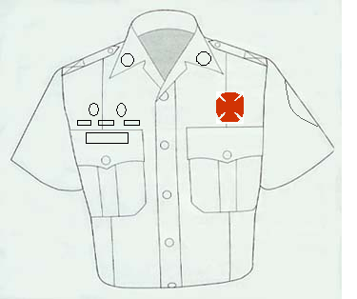

Award Pins |  |  |  |  |  |  | Station
 |  |  |  |  |  |  | Patch
Name Bar |  |  |  |  |  |  | Badge

Uniforms and Protective Equipment are issued to Junior members by the Junior program quartermaster. All issued items remain the property of the Elkridge Volunteer Fire Dept., and must be surrendered upon termination of the membership.

A uniform will be issued. The uniform includes:
- White or Powder Blue shirt (for parades/public functions)
- Junior Department Patch (affixed to the above shirt)
- T-Shirt (for trainings/other functions)
- Collar Pins
(The badge may be purchased from the quartermaster and will be yours to keep upon purchase. Name bars are issued at the annual banquet.) Black closed toe footwear and navy blue pants must be purchased by each individual.

You are responsible for the care and maintenance of your uniforms. They are to be worn when participating in any departmental function or activity where you will have contact with members of the public. Uniforms are also required to be worn during training, unless told otherwise by a Director. The uniform is not provided for your daily wear. It is not to be worn while off duty except to travel to and from the station.

Personal Protective Equipment will also be provided for you. The Personal Protective Equipment consists of the following:
- Safety Glasses
- Hearing Protection
- Protective Gloves
- Short Length of Rope
and depending on availability:
- Fire Helmet
- Turn-Out Pants
- Turn-Out Coat
- Boots

You are responsible for the care and upkeep of your safety equipment. All equipment MUST be brought to training events.

Junior’s Point System

Parades - 1 point per hour.
Meetings - 1 point per meeting.
Training - 1 point per training.
Officers - 2 points per month.
Committees - 2 points per month if the committee is active for that month; also 1 extra point for being a chair of that committee.
Sleep-Ins - 2 points per sleep-in or any other call monitoring training period.
Fundraisers - 1 point per hour and ½ point per ½ hour. Fundraisers are moneymaking events for the Fire Department or the Junior Program and include dances, dinners, breakfasts, car washes, etc.
Community
Relations - 1 point per hour, ½ point per ½ hour. Will not be broken down any less than ½ hour increments. Points will be given for public relation details are such as the fire expo, open house, fire prevention details, Adopt-A-Road, helping the CERT team, or time spent doing things around the fire house.

Points will only be given if a Junior signs in and out on a sign-in sheet.

Juniors Attendance Sheet will be filled out as follows:
A Junior officer will fill out the date, then circle the event type. If this is a meeting, then put in the type of meeting. If the event is not listed, then circle other and fill in the type. Each Junior will find their name and EID number, sign the sheet under the signature column, put the time you start in the time in column, and the time you finish in the time out column. The gray hours section is to be filled out by the point’s committee. An advisor or parent in charge must then sign the sheet. Completed sign-in sheets are to be placed in the points box.

Please sign in on the ½ hour and the hour. If signed for any other time increment time will be rounded off to the nearest ½ hour, all times should be written in military time.

Military Time Conversion
1:00 a.m. – 0100 hrs 1:00 p.m. – 1300 hrs
2:00 a.m. – 0200 hrs 2:00 p.m. – 1400 hrs
3:00 a.m. – 0300 hrs 3:00 p.m. – 1500 hrs
4:00 a.m. – 0400 hrs 4:00 p.m. – 1600 hrs
5:00 a.m. – 0500 hrs 5:00 p.m. – 1700 hrs
6:00 a.m. – 0600 hrs 6:00 p.m. – 1800 hrs
7:00 a.m. – 0700 hrs 7:00 p.m. – 1900 hrs
8:00 a.m. – 0800 hrs 8:00 p.m. – 2000 hrs
9:00 a.m. – 0900 hrs 9:00 p.m. – 2100 hrs
10:00 a.m. – 1000 hrs 10:00 p.m. – 2200 hrs
11:00 a.m. – 1100 hrs 11:00 p.m. – 2300 hrs
12:00 p.m. – 1200 hrs 12:00 a.m. – 0000 hrs

Points are used to monitor participation and interest in the program. Awards and privileges may also be given based upon the level of points earned. A lack of points may indicate that participation and interest in the program are not satisfactory.

Frequently Asked Questions

This is a list of the questions asked most often by new Junior Members:

Q: What activities do you have in this program?
A: We hold trainings, social activities such as dances, fundraising events, public service projects, and other things that a firefighter does except for fighting fires.

Q: Do we get to participate in parades?
A: Yes. Parades are usually held in the summer months. The Junior department will typically march along with the advisors and any parents wishing to participate. uniors MUST have a uniform issued to them before they are able to participate in a parade.
Q: How will I find out about different events taking place?
A: Events are announced at trainings, meetings, e-mails and in newsletters. In addition, you may be contacted by the sergeant in charge of your platoon. (Especially if there is a change or short notice.)

Q: What is the cost of the program?
A: Dues are $5.00 each year. In addition, you are responsible for the cost of any field trips, and uniform items not provided by the department.

Q: How do I know how many points that I have?
A: Points are posted on the Junior Program bulletin board. Point sheets are also available at trainings to check your points.

Q: When can I start fighting fires and perform emergency medical services?
A: On your 16th birthday you are eligible to apply to the active department (with parental consent). At that time, you may begin the required formal training to be certified as a Firefighter and/or Emergency Medical Technician (EMT). The Juniors have an advantage in that the program makes them familiar with many of the tools, techniques, and safety issues required for Firefighting and Emergency Medical Services (EMS).

Q: Can I participate in the Junior Program after my 16th birthday?
A: After your 16th birthday, you must apply to the Active Department as an Operational or Associate member in order to participate. Upon acceptance into the Active Department, you must resign as a Junior Member. However, former Junior members are strongly encouraged to continue to help with the Junior Firefighter Program.

Q: If I have questions or problems, who do I talk to?
A: The Junior officers are available to answer questions and to assist you. In addition the advisors will help you with any questions, and any problems and conflicts must be addressed directly with an advisor.

Q: Do I have to participate in trainings and other events?
A: YES! The goals of the Junior program can not be met for an individual who does not participate in the trainings or other events. A lack of participation may result in the loss of certain privileges and/or the ability to participate in certain activities. Individuals who regularly do not participate in the Junior department activities without notifying an Advisor may be dropped from the program.

Q: Can I ride the apparatus and fight fires as a Junior Firefighter?
A: Since firefighting is dangerous and requires specialized training, you must first join the Active Department in order to participate in these activities. Quite often, Juniors are permitted to ride the apparatus that is not in service while going to and coming from parades, or other public service events.

