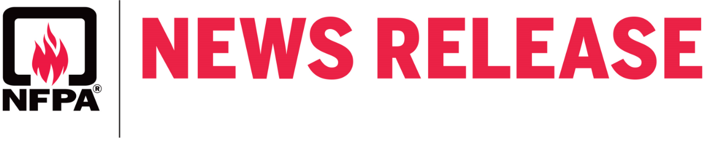
Contact: Lorraine Carli
Public Affairs Office: +1-617-984-7275 For immediate release
publicaffairs@nfpa.org

As public fireworks displays are canceled across the country,
NFPA urges people to refrain from using consumer fireworks
when celebrating on and around July 4

June 10, 2020 – In a typical year, the National Fire Protection Association (NFPA) encourages the public to only attend public fireworks displays put on by trained professionals, reflecting its’ long-standing position against consumer use of fireworks. However, with public fireworks events around the country being canceled this year, NFPA is vigorously discouraging individuals’ use of consumer fireworks, recognizing that the likelihood of such activities may increase in the absence of public displays.

Fireworks video is available.

“While fireworks are an emblem of July 4 celebrations, in the absence of public displays this year, we strongly encourage people to find safe and creative alternatives for celebrating the holiday,” said Lorraine Carli, vice president of Outreach and Advocacy at NFPA. “Fireworks are simply too dangerous and unpredictable to be used safely by consumers. Even sparklers, which are often considered harmless enough for children, burn as hot as 1,200 degrees Fahrenheit and can cause third-degree burns.”

In addition to the harm consumer fireworks can inflict on individuals, Carli notes that fireworks’ incidents place undue burdens on first responders and emergency room staff.

“First responders and our health care services have been working tirelessly to protect the public throughout the COVID-19 pandemic,” said Carli. “A great way for people to show their support is to avoid consumer use of fireworks and help minimize the number of avoidable incidents that require response and care.”

Fireworks started an estimated 19,500 fires in 2018, including 1,900 structure fires, 500 vehicle fires, and 17,100 outside and other fires. These fires caused five deaths, 46 civilian injuries, and $105 million in direct property damage.

According to the U.S. Consumer Product Safety Commission (CPSC), U.S. hospital emergency rooms treated an estimated 9,100 non-occupational fireworks related injuries; burns accounted for 44 percent of the fireworks injuries seen in the month around July 4. Half of the fireworks injuries seen at emergency rooms around the month of July 4, 2018 were to extremities, particularly the hand or finger,

Fireworks 2020
Page 2 of 2

or leg. One-third were to the eye or other parts of the head. Children ages 10-14 had the highest rate of fireworks injury, with more than one-third (36 percent) of the victims of fireworks injuries in this period under age 15.

“Fireworks cause thousands of needless fires and injuries each year,” said Carli. “By simply choosing not to use consumer fireworks, these types of incidents can be easily prevented, lessening the strain on already overtaxed first responders and emergency room workers.”

For this release and other announcements about NFPA initiatives, research and resources, please visit the NFPA press room.

As all of us continue to navigate the evolving situation with COVID-19, NFPA remains committed to supporting you with the resources you need to minimize risk and help prevent loss, injuries, and death from fire, electrical, and other hazards. For information on NFPA’s response to the coronavirus, please visit our webpage.

About the National Fire Protection Association (NFPA)
Founded in 1896, NFPA is a global self-funded nonprofit organization devoted to eliminating death, injury, property and economic loss due to fire, electrical and related hazards. The association delivers information and knowledge through more than 300 consensus codes and standards, research, training, education, outreach and advocacy; and by partnering with others who share an interest in furthering the NFPA mission. For more information, visit www.nfpa.org. All NFPA codes and standards can be viewed online for free at www.nfpa.org/freeaccess.

sm:42

-30-

