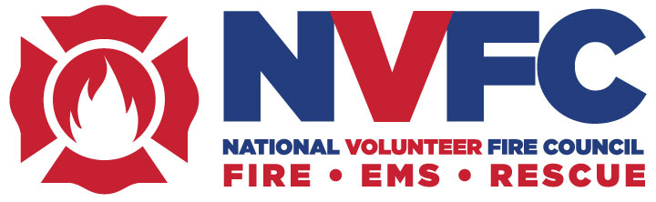

7852 Walker Drive, Suite 375, Greenbelt, MD 20770; 202-887-5700 phone; 202-887-5291 fax
www.nvfc.org email: nvfcoffice@nvfc.org

NVFC Volunteer Firefighter Support Fund
Individual Assistance Application

The National Volunteer Fire Council (NVFC) has established the NVFC Volunteer Firefighter Support Fund to assist active volunteer firefighters, rescue workers, and EMS personnel whose home/housing has been impacted by a state- or federally-declared disaster or fire. Individual stipends of up to $350 are awarded to eligible applicants to assist in meeting essential needs in the wake of a disaster or fire, as funds allow. The NVFC has temporarily expanded the eligibility to those who have suffered an involuntary loss of wages as a result of COVID-19. In order to qualify, individuals must:

- Be from an NVFC member state as an individual or department member of the state association, or an NVFC member
- Be an active volunteer firefighter, rescue worker, or EMS provider
- Live (have your primary residence) in a state- or federally-declared disaster area or have suffered home damage due to fire, or have incurred an involuntary loss of wages in excess of $500 as a result of COVID-19
- In the instance of a home fire, the applicant must certify that there were no intentional acts of arson or fraud and that there were working smoke alarms in the residence placed according to code.
- Have incurred an uninsurable loss in excess of $5,000 (only applies to the state or federally declared disaster, not to the personal fire loss or loss of wages as a result of COVID-19).
- Applications must be received by the NVFC within 60 days after the incident occurred.

All applications are reviewed by the NVFC Director from the applicant’s state fire association. The NVFC may also contact your department’s chief for approval of the application.

If it is determined that there was impropriety, fraud, or arson, or that any information submitted on the application is intentionally false or misleading, the NVFC reserves the right to seek the return of the stipend.

Applications for assistance can be submitted via mail, email, or fax to the contact information above.

Applicant Name: Click here to enter text.

Permanent Address: Click here to enter text.

City, State Zip: Click here to enter text.

Phone Number: Click here to enter text. Email: Click here to enter text.

Name of Fire/EMS/Rescue Department: Click here to enter text.

Title in the Department: Click here to enter text.

Are you an active volunteer firefighter, rescue worker, or EMS provider? Yes ☐ No ☐

Do you live or have housing in a state- or federally-declared disaster area or suffer home damage due to fire? Yes ☐ No ☐

For loss from a state- or federally-declared disaster only: Did you incur an uninsurable loss in excess of $5,000? Yes ☐ No ☐

For loss from a home fire only: I certify that there were no intentional acts of arson or fraud and that there were working smoke alarms in the residence placed according to code. Yes ☐ No ☐

Have you incurred an involuntary loss of wages in excess of $500 due to COVID-19? Yes ☐ No ☐

Are you from an NVFC member state as an individual or department member of the state association, or an NVFC member? Yes ☐ No ☐

Please provide a brief but specific description of how the disaster impacted you and why you need this assistance. For instance, if applying for assistance due to COVID-19, please include details on your employment and an estimate of lost wages.

Click here to enter text.

Date of incident: Click or tap to enter a date.

Address and phone number where you can be reached and check should be mailed (if different from above):

Click here to enter text.

Fire Chief’s Name– please note your chief may be contacted by the NVFC for application approval:
Click here to enter text.

Fire Chief’s Email: Click here to enter text.

Fire Chief’s Phone Number: Click here to enter text.

My signature certifies that all information is true to the best of my knowledge.

__________________________________________________________________________________
Applicant’s Signature Date

For NVFC staff use only
☐ Approved Date _______________
☐ Not Approved Date _______________ Reason _________________________________________

